

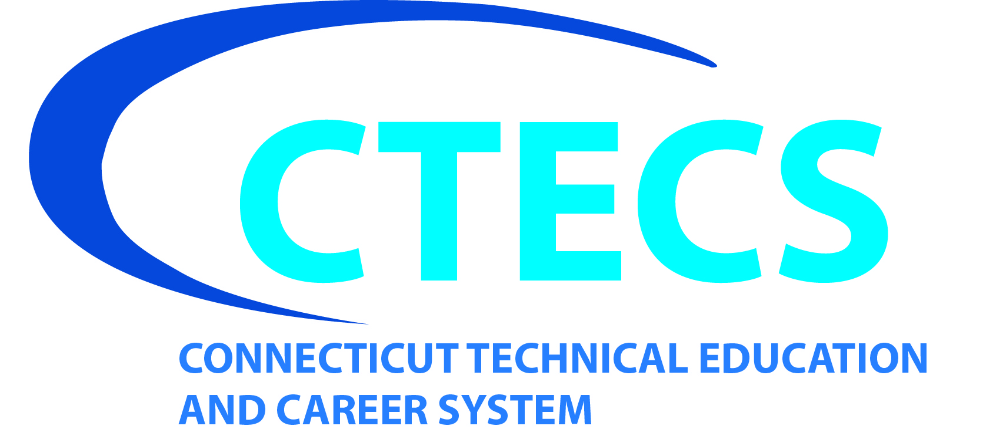
Bristol Technical Education Center

Connecticut Technical Education & Career System

431 Minor Street, Bristol, CT, 06010

860-584-8433 / Fax: 860-584-0795

bristol.cttech.org

BTEC 2023-2024 – Full-Time Adult Program Application
(Priority Application Deadline – extended to May 1, 2023)

Application Requirements & Procedures:
□ Complete this application in its entirety.
□ Include a copy of your final high school transcript or General Educational Diploma (GED).
□ Submit completed application via email or post mail to: Domenica.Holman@cttech.org
Or
Bristol Technical Education Center, C/O Guidance Office
431 Minor Street Bristol, CT 06010

□ Take Admission Test – Applicants must contact Mrs. Holman, School Counselor, at Domenica.Holman@cttech.org or (860) 584-8433 ext. 335, to set up admission testing. All tests are administered at the Bristol Technical Education Center. An admission test fee of $50 must be paid on the day of testing at Bristol Tech. (Refer to page 4 for payment methods)

*Admissions is contingent upon post-graduates attending an orientation session and clearing a history of criminal arrest.
*Applicants who received Special Education or related services in high school and have a summary of performance may include it with the application for us to review in order to help meet your educational needs.

Personal Information

Full Name: ______________________ (_________________)____________________________________________________
(Last) (Prior Name) (First) (Middle)

Address: _______________________________________________________________________________________________
(P.O. Box, Apartment, Street Name and Number)

________________________________________________________________________________________________________
(City or Town) (State) (Zip Code)

Mailing Address: ________________________________________________________________________________________
(If different) (P.O. Box, Apartment, Street Name and Number)

________________________________________________________________________________________________________
(City or Town) (State) (Zip Code)

Birth Date: ___________________ Place of Birth: _______________________________________________________
(Month/Day/Year) (City) (State) (Country)

Home Phone: ( ) ______________________________ Cell Phone: ( ) ____________________________________

Email address: __________________________________________________________________ (Please print clearly)

BTEC Applicants - Technology Area: 1st Choice: ____________________________ 2nd Choice: _________________________

BTEC Choices Include:

- Automotive Technology - 2 year
- Culinary Arts - 1 year
- Mechatronics Technology - 1 year
- HVAC/R - 2 year
- Precision Machine Technology - 1 year
- Welding & Metal Fabrication – 1 year

General Information

This application requests general information about your national origin, gender, racial or ethnic group, and primary language spoken in the home. Providing this information is voluntary. The information provided will be used for record-keeping purposes only. It will not be used as a factor in any action concerning education, activities or employment.

Gender: □ Male □ Female Racial or Ethnic Group: □ American Indian or Alaskan Native (1)
□ Asian American or Pacific Islander (2)
□ Black (3)
□ White (4)
□ Hispanic (5)
Primary Language: _____________________________________________

High School graduate? □ Yes □ No

If yes, name of High School: _________________________________________

If no, do you have a GED certificate? □ Yes □ No

NOTE: A copy of a High School transcript or GED certificate must be included with this application.

Are you a U. S. Veteran? □ Yes □ No Dates of Service _____________ - _____________

Type of discharge: _____________________________________________________________

Have you attended/applied to another Connecticut Technical High School? □ Yes □ No

If you answered yes, name of school: _________________________________________________________

Have you ever been convicted of any crime? □ Yes □ No

Are there any criminal charges pending against you? □ Yes □ No

If you have answered yes to either of these questions, attach a sheet providing specific information. If conviction of a crime or pending criminal charges is a basis for rejection, you will be notified in writing and you will be provided an opportunity to request reconsideration (see CGS 46a-79 and 80). Failure to disclose a conviction or pending criminal charges will be a basis for rejection, or dismissal if enrolled.

It is the policy of the Connecticut Technical Education & Career System that no person shall be excluded from participation in, denied the benefits of, or otherwise discriminated against under any program, including employment, because of race, color, religious creed, sex, age, national origin, ancestry, marital status, sexual orientation, or disability (including, but not limited to, mental retardation, past or present history or mental disorder, physical disability or learning disability), genetic information, or any other basis prohibited by Connecticut state and/or federal nondiscrimination laws. The Connecticut Technical Education & Career System does not unlawfully discriminate in employment and licensing against qualified persons with a prior criminal conviction. Inquiries regarding the Connecticut High School System’s nondiscrimination policies and practices should be directed to Superintendent of Schools, Connecticut Technical Education & Career System, 39 Woodland Street, Hartford, CT 06105, and/or, regarding race, color, national origin, age, sex and/or disability to the Office for Civil Rights,
U.S. Department of Education, Boston, MA 02110-1491, telephone 617.289.0111, fax 617.289.0150, TTY/TDD 877.521.2172. The Connecticut Technical Education & Career System is an equal opportunity/affirmative action employer.

The following information will help us know more about you and what experiences you may have related to the technology area. Please complete the following. Attach additional sheets if needed.

Educational Background
Institutional Name  City, State | Attendance  From To |  | Certificate/Award  Diploma or Degree Earned

Work Experience:
Company Name  City, State | Dates  From To |  | Job Title & Duties

Volunteering:
Organization Name  City, State | Dates  From To |  | Work Done

Hobbies/Interests:
Please write an interest statement and explain why you have chosen BTEC and what your career plans are. (Attach an additional sheet if needed.)

Please tell us how you heard about the adult education programs at BTEC.
□ Word of Mouth □ Newspaper Ad □ Newspaper Article □ TV/Radio Ad □ Career Fair
□ Internet □ Presentation □ Vocational Counselor □ other _____________________

I hereby certify that the information provided by me in this application is true, complete and accurate. I understand that applications will not be returned.

_________________________________________________ ________________________
Signature of Applicant Date

__________________________________________________ ________________________
Parent Signature (if under 18 years of age) Date

Connecticut Technical Education and Career System (CTECS)
2023-2024 Full-Time Adult Student Information/Financial Obligation

Tuition and Fees

The tuition and fee schedule for 2022-2023 academic year as approved by the Connecticut State Board of Education are as follows:

Program | Resident/  Non-Resident | Tuition | Admission Test Fee | Payment Due Dates
Aviation | Resident | Total of $7,200 payable in three installments over two years ($2,400 per installment) | $50.00  Due on day of test | Date of first  scheduled class of each “block”
Bristol T.E.C. | Resident | Total of $4,000 payable in two installments over one year ($2,000 per installment) | $50.00  Due on day of test | Date of first  scheduled class of each “semester”

Acceptable methods of payment

- Bank check or money order made payable to “Treasurer, State of Connecticut” for the exact amount due;
- Cash will be accepted in the school business office only during regular business hours (8:30 a.m. – 2:00 p.m.)

Unacceptable methods of payment

- Personal checks;
- Debit and Credit cards;
- Cash (except during normal business hours);

Other financing options (It is the responsibility of the student to initiate and follow up on the methods listed below):

The Connecticut Technical Education and Career System offers other financing options including:

- Financial Aid - Students enrolled in a full-time program may apply for a Federal Pell Grant;
- Outside agencies Funding from other state agencies (i.e. Dept. of Labor, Office of the State Comptroller);
- G.I. Bill Veteran Education Benefits

**Any student failing to pay or be approved for an alternative financing option by the payment due date will be immediately dismissed from their program of study. As regular attendance is a critical aspect of the educational process, students with attendance problems may be dismissed from the program.

Connecticut Technical Education and Career System (CTECS)
2023-2024 Full-Time Adult Student Information/Financial Obligation

Applying for a tuition waiver

Eligible students wishing to apply for a tuition waiver must complete a Tuition Waiver Request form, (available at, https://www.cttech.org/adult-education/) no later than four weeks prior to the first class session.

- Veterans requesting a tuition waiver must attach a copy of their Certificate of Release or Discharge (DD Form 214) (90 days of honorable active duty service in addition to that spent in active duty training and in attendance at military service academies for any war period after August 2, 1990 or engaged in combat or in combat support role in specific conflicts prior to August 2, 1990);

- Senior Citizens – Students age 62 and over requesting a waiver must attach a copy of their proof of age;

- Unemployment compensation is NOT a means-tested benefit program and therefore is not considered when determining financial hardship;

- Students whose tuition is being paid by another state agency must submit written documentation (i.e. voucher) identifying the agency responsible for payment.

- Students receiving educational assistance benefits under the G.I Bill from the Veterans Administration must submit enrollment verification or training agreement. The student should provide the school Certification Officer, VA Form 22-1999 and VA Form 22-1999b for submission to the Veterans Administration to receive the education benefits payment form VA.

- If a student is denied a tuition waiver, all tuition and fees are due by the next class session.

Applying for a Federal Pell Grant

- Admitted students must complete the Free Application for Federal Student Aid (FAFSA). It is recommended that the student completes the FAFSA after completion and submission of the prior year’s IRS tax return in order to avoid delay and having to go back to change information or making corrections. The completion and submission of the prior year’s IRS tax return will allow the student and or parent(s) to use the IRS data retrieval tool when prompted during the FAFSA completion and will provide accurate financial information and therefore expedite the award process.

- Admitted students must submit a valid Student Aid Report (SAR) and complete a CTECS Financial Aid Application Packet available from the school’s financial aid liaison.

- Applicants applying and accepted for a program can still apply for a Pell Grant.

- If a student is deemed ineligible for financial aid, outstanding tuition is due five days following receipt of the denial notification.

- If a student is notified that their financial aid award will not cover the entire semester tuition cost, all tuition and fees are due five days following receipt of the award notice or by the regular tuition deadline, whichever is later.

- The federal government randomly selects Pell Grant applications for verification. If your application is selected for verification, you will be notified by the Financial Aid Administrator and additional supporting documentation must be submitted by the specified deadline.

Procedures for Withdrawal

In order to officially withdraw from an adult education program in the CTECS and be considered for a tuition refund, candidates must complete and submit to the school‘s Guidance Office, the following two documents available from the district’s Adult Education webpage (http://www.cttech.org/adult-education.html):

- Student Withdrawal Form
- Request for Tuition Refund Form (Appendix IX)
Students may be eligible for a tuition refund upon approval of the Student Withdrawal Form by a school administrator (Principal or Assistant Principal)

Connecticut Technical Education and Career System (CTECS)
2023-2024 Full-Time Adult Student Information/Financial Obligation

Eligibility for Tuition Refunds

- Except for withdrawal due to military action or serious illness, if the Student Withdrawal Form is received from the student prior to the first scheduled class session, the student is eligible for a 100% tuition refund.

- Except for withdrawal due to military action or serious illness, if the Student Withdrawal Form is received from the student after the first scheduled class session, but prior to the fourteenth (14th) calendar day from the first scheduled class session, the student is eligible for a 60% tuition refund.

- Except for withdrawal due to military action or serious illness, if a Student Withdrawal Form is received after the fourteenth (14th) calendar day from the first scheduled class session; the student is not eligible for a tuition refund.

- All requests for tuition refunds due to military action and supported by written documentation from the military are eligible for 100% tuition reimbursement;

- All requests for tuition refunds due to serious illness and supported by written documentation from a medical professional are also eligible for 100% tuition reimbursement;

Processing of Tuition Refunds

If the student meets the eligibility requirements for a tuition refund, the Request for Tuition Refund Form (Appendix IX) completed by the student will be forwarded from the school administrator to the school’s business office and then to the State Department of Education’s (DOE) Payments Unit.

The SDE Payments Unit will then issue a state invoice utilizing the State of Connecticut’s official accounting system (CORE-CT) and transmits the invoice to the State Comptroller for issuance of a refund check payable to the student within the state’s payment timelines (currently net 45 days).

I have read and understand the above:

Student Signature______________________________
Printed Name _________________________________
Date______________

We offer a unique and rigorous learning environment that:
• Ensures both career technical education mastery and student success, as well as promotes enthusiasm for lifelong learning;
• Prepares students for apprenticeships, immediate productive employment, as well as continuing education; and
• Engages regional and state employers, industry partners, CTEC representatives, our sending schools, and members of our family community in a vibrant collaboration that responds to current, emerging and changing workforce needs and expectations.
We offer a unique and rigorous learning environment that:
• Ensures both career technical education mastery and student success, as well as promotes enthusiasm for lifelong learning;
• Prepares students for apprenticeships, immediate productive employment, as well as continuing education; and
• Engages regional and state employers, industry partners, CTEC representatives, our sending schools, and members of our family community in a vibrant collaboration that responds to current, emerging and changing workforce needs and expectations.
We offer a unique and rigorous learning environment that:
• Ensures both career technical education mastery and student success, as well as promotes enthusiasm for lifelong learning;
• Prepares students for apprenticeships, immediate productive employment, as well as continuing education; and
• Engages regional and state employers, industry partners, CTEC representatives, our sending schools, and members of our family community in a vibrant collaboration that responds to current, emerging and changing workforce needs and expectations.

We offer a unique and rigorous learning environment that:
• Ensures both career technical education mastery and student success, as well as promotes enthusiasm for lifelong learning;
• Prepares students for apprenticeships, immediate productive employment, as well as continuing education; and
• Engages regional and state employers, industry partners, CTEC representatives, our sending schools, and members of our family community in a vibrant collaboration that responds to current, emerging and changing workforce needs and expectations.

